**5472-JEAS Revised (WARSE)**

**Augmented Reality as a Data Visualization Tool**

Suresh P1, Kiran M2, Bhavyasri B Shetty3, G D Nagasree4, Kavya M5

Department of Computer Science and Engineering, Sri Venkateshwara College of Engineering  
Vidyanagar, Bengaluru 562-157, Karnataka, India

[suresh.rvce@gmail.com](mailto:suresh.rvce@gmail.com)

[kiran.kite96@gmail.com](mailto:kiran.kite96@gmail.com)

[bhavya.d2701@gmail.com](mailto:bhavya.d2701@gmail.com)

[nagasreegd@gmail.com](mailto:nagasreegd@gmail.com)

[kavyamanjunath96@gmail.com](mailto:kavyamanjunath96@gmail.com)

***Abstract***—**During the last few years, Data visualization has seen a drastic turnover, with a growing need in various field. The ease of conveying data and analytics has made it more popular and trending. Data visualization has evolved with various methods and visualization tools. As an evolving tool, it has shown to be applicable across several fields. Hence, it could use a better and more user interactive visualization tool. And we present the current trending tech, Augmented Reality(AR), as a data visualization tool.**

***Keywords*—Data Visualization, Augmented Reality (AR)**

1. Introduction

D

uring the last few years, data has been growing in size, variety, numbers of users and diversity of applications. Many such applications deal with data characterized by the temporal dimension (e.g. medical records, biographical data, financial data, etc.). Typically, end-users of these data are competent in the field of the application but are not computer experts. They need easy-to-use systems that are able to support them in the task of accessing and manipulating the data contained in the databases. It is well-known that visual techniques are suitable in supporting users interacting with large data sets [1].

Information/data visualization is traditionally viewed as a tool for data exploration and hypothesis formation. Because of its roots in scientific reasoning, visualization has traditionally been viewed as an analytical tool for improved understanding. In recent years, however, both the mainstreaming of computer graphics and the democratization of data sources on the Internet have had important repercussions in the field of information visualization. With the ability to create visual representations of data on home computers, artists and designers have taken matters into their own hands and expanded the conceptual horizon of infovis as artistic practice. This paper presents a brief survey of projects in the field of artistic information visualization and a preliminary examination of how artists appropriate and repurpose “scientific” techniques to create pieces that actively guide analytical reasoning and encourage a contextualized reading of their subject matter [2].

In our current era, information is being generated at such a massive rate that organizations are struggling to keep up with the demand being generated. Never before in history has data been generated at such high volumes as it is today. Exploring and analysing the vast volumes of data has become increasingly difficult. Information visualization and visual data mining can help to deal with massive storm of information that floods our databases.The advantage of such is that the user can be directly involved in the data-mining process. Numerous visualization techniques have been developed over the last few years to explore vast datasets [3].

In this day and age, data or information is power, or the currency through which transactions are carried out. The internet provides a framework to allow such transactions to occur between entities. Consumers are constantly being flooded with data; from communication medium to the labels on soft drinks. Due to this massive increase in data transactions or visualization, designers or advertisers find it increasingly difficult to project a unique perspective.

One of the best ways to get your message across is to use a visualization to quickly draw attention to the key messages, By presenting data visually, it's also possible to uncover surprising patterns and observations that wouldn't be apparent from looking at stats alone. And nowadays, there's plenty of free graphic design software to help you do just that.

As author, data journalist and information designer David McCandless said in his TED talk: "By visualizing information, we turn it into a landscape that you can explore with your eyes, a sort of information map. And when you're lost in information, an information map is kind of useful."[5].

There are many different ways of telling a story, but everything starts with an idea. And with help of various tools available on the web, representing data hasbecome more creative and interesting with out of box idea [4].

The rest part of the paper is organized as follows: Section II describes the proposed existing tools, Section III proposed system, Section IV describes Augmented Reality principals and working and Section V gives the conclusion and future scope of work and references are at the end.

1. Existing Tools

In this section, we present some of the tools which already exist on web for data visualization.

1. *Plotly*

Helpful in Making charts, presentations and dashboards with this flexible software. You can perform your analysis using JavaScript, Puthon, R, Matlab, Jupyter or Excel, and there are several options for importing data. The visualisation library and online chart creation tool allow you to make great-looking graphics.

1. *DataHero*

DataHero enables you to pull together data from cloud services and create charts and dashboards. No technical abilities are required, so this is a great tool for your whole team to use.

1. *Chart.js*

Although armed with only six chart types, open source library Chart.js is the perfect data visualization tool for hobbies and small projects. Using HTML 5 canvas elements to render charts, Chart.js creates responsive, flat designs, and is quickly becoming one of the most popular open-source charting libraries.

1. *Tableau*

Packed with graphs, charts, maps and more Tableau public is a popular data visualization tool that's also completely free. Users can easily drag and drop data into the system and watch it update in real-time, plus they can collaborate with other team members for quick project turnaround.

1. *Raw*

Open, customizable, and free to download and modify, Raw lets users create vector-based data visualizations. Data can be safely uploaded from apps to computers, plus it can be exported as an SVG or PNG and embedded in your webpage.

1. *Dygraphs*

Dygraphs is a fast, flexible open source JavaScript charting library that allows users to explore and interpret dense data sets. It's highly customizable,works in all major browsers, and you can even pinch to zoom on mobile and tablet devices.

As seen in the list, the tools existing in the market provide a very flexible backend support for scrapping and collecting data and provide a good graphical representation. Although the representation is pretty interactive, the representation is limited to 2D dimensional viewport, even if a model is 3D.

1. PROPOSED MODEL

Referring to the paper [6][9], a model has been proposed on how augmented realities (AR) can be used in architecture for better understanding and designing 3D models as the upcoming AR technology is becoming very popular among various fields, for its augmented real-time model, presentation and user interaction.

AR can project 3D models which can be viewed in real world hence providing a view from multiple angles for viewing, which is advancement over previous model which provided only view from 2D window view. And is very user interactive because it can be viewed from multiple angles. Hence a better data representation for fast data analytics. More about AR is explained in section VI.

1. AUGMENTED REALITY PRINCIPLE AND WORKING

Augmented reality (AR) is a live direct or indirect view of a physical, real-world environment whose elements are augmented (or supplemented) by computer-generated sensory input such as sound, video, graphics or GPS data. It is related to a more general concept called mediated reality, in which a view of reality is modified (possibly even diminished rather than augmented) by a computer. As a result, the technology functions by enhancing one’s current perception of reality. By contrast, virtual reality replaces the real world with a simulated one. Augmentation is conventionally in real time and in semantic context with environmental elements, such as sports scores on TV during a match.

With the help of advanced AR technology (e.g. adding computer vision and object recognition), the information about the surrounding real world of the user becomes interactive and digitally manipulable. Information about the environment and its objects is overlaid on the real world. This information can be virtual or real, e.g. seeing other real sensed or measured information such as electromagnetic radio waves overlaid in exact alignment with where they actually are in space. Augmented reality brings out the components of the digital world into a person's perceived real world. One example is an AR Helmet for construction workers which displays information about the construction sites. The first functionalAR systems that provided immersive mixed reality experiences for users were invented in the early 1990s, starting with the Virtual Fixtures system developed at the U.S. Air Force's Armstrong Labs in 1992.

In simple terminology, augmented reality (AR) uses computer-aided graphics to add an additional layer of information to aid understanding and/or interaction with the physical world around you. This is commonly exemplified through adding additional, rich digital information (or computer models), which are displayed through some sort of visual output screen.

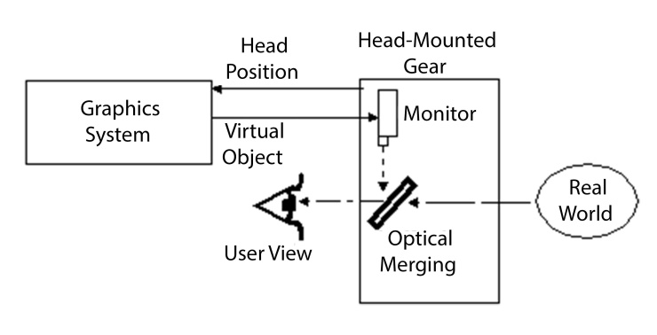

*Fig1. Working of AR*

The above figure illustrates the working. The graphics system generates the virtual objects which are to be projected, and is supplied to the monitor. The monitor captures the real-world view. The real-world view is merged with the virtual objects and is displayed on the screen of the monitor, is the user view. Hence, user sees a projection of virtual objects in the real world.

On a technical level, the methods by which AR is achieved can generally be split into two broad categories: Marker-based and Markerless.

*3.1 Marker-based Systems*

In **marker based Augmented Reality** applications **the images** which has to be provided will be provided or recognized before they are used. In this case given we will knowing *exactly*  , whatever the camera data are captured has to be searched by the application apriori. In the modern technology which are marker based AR the image recognition has been made mandatory, Since it will make more things to be detected in a simpler way that are hard-coded in your app.

The technology uses physical-world symbols as a reference point for computer graphics to be overlaid. For example, a 2-dimensional printed marker is placed in front of a webcam. The computer then interprets this symbol to overlay an on-screen graphic as if it were directly on top of the marker in the physical world. There have been several notable uses, most commonly in marketing as demonstrated above.

Educational applications of Marker-based AR could include 3-D modelling of geographic data (photo below). Numerous other examples include some fantastic e-learning AR resources for the national curriculum and a 3D sketch-to-model visualization tool.

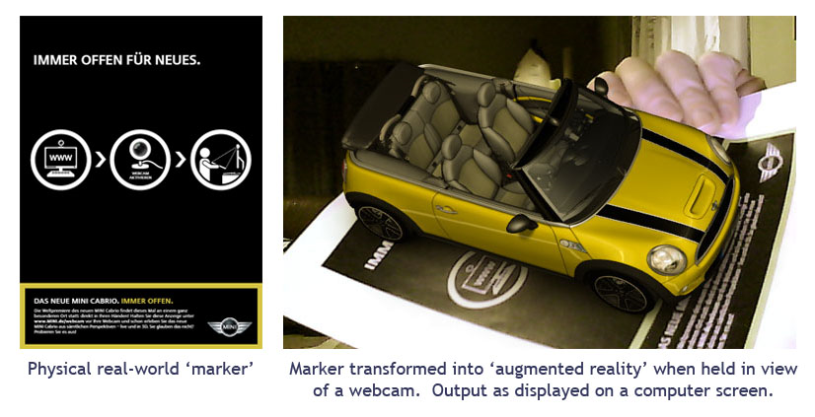

***Fig 4.1 Promotional AR of app[4]***

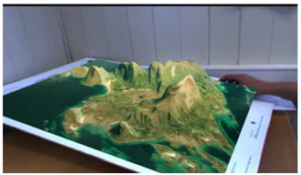

***Use of Marker-based AR to understand landscapes in geography***

***Fig 4.2 Map ElevationsAR[4]***

* 1. *Markerless Systems*

By contrast, this technological approach has given rise to ‘mobile augmented reality’, denoting use of the technology with devices such as smartphones and tablets. This method uses a combination of an electronic devices’ accelerometer, compass and location data (such as the Global Positioning System – GPS) to determine the position in the physical world, the direction pointer and on which axis the device is operating.

This location data can them be compared to a database to determine what the device is looking at, and thus allows computer data/graphics to be displayed on-screen. Recent innovative applications include an iPhone app allowing lost Londoners to determine whichUnderground station is Educational uses of thisclosest. Technology centre around approaches of discoverable learning: allowing learners to find their own pathways through content. Use of markerless technologies in education is an emerging area, yet some initial applications have appeared. CultureClic’s Augmented Culture for iPhone allows users to explore museums and cultural attractions in selected French cities without even stepping inside the buildings.

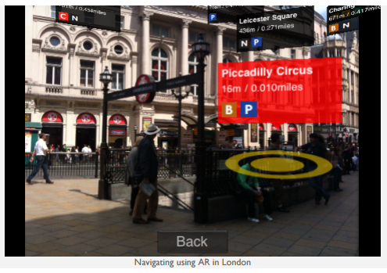

*Fig 4.3 Navigation AR app[4]*

Furthermore, and although not showing ‘reality’ on-screen, Google Sky Map provides a further example of how location data from mobile devices can aid understanding and navigation of the night skies.

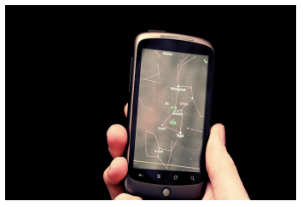

*Fig.4.4 Google Sky Map*

1. Conclusion and future scope

With AR beginning to proliferate across a variety of applications in the consumer mass-market, educationalists have begun to look more closely at the potential these new technologies offer for learning. Hamilton &Olenewa (2010) describe how augmented reality can provide a rich contextual environment for learning, citing several possible uses of the technology including potential for skills training; discovery based learning as well as modelling objects.

And using it as a Data visualization tool will increase user interactivity and will open horizons across several disciplines and markets.

Further analysis argues these technologies appeal to constructivist notions of education where students take control of their own learning, whilst also providing opportunities for more authentic learning, appealing to multiple learning styles, data visualization, analytics and easier data presentation.

Whilst this relatively infant technology is yet to achieve mass-market awareness amongst target audiences, the rapid pace of innovation offers inventive applications and user-interface improvements every day, all suggesting that this technology has real potential for informing high quality learning, visualization and analytics [7].

The exploration of large datasets is an important but difficult problem. Information visualization techniques can be useful in solving this problem. Visual data exploration has very high potential, and many applications such as fraud detection and data mining can use information visualization technology for improved data analysis. Avenues for future work include the tight integration of visualization techniques with traditional techniques from such disciplines as statistics, machine learning, operations research, and simulation. Integration of visualization techniques and these more established methods would combine fast automatic data-mining algorithms with the intuitive power of the human mind, improving the quality and speed of the data-mining process. Visual data-mining techniques also need to be tightly integrated with the systems used to manage the vast amounts of relational and semi-structured information, including database management and data warehouse systems. The ultimate goal is to bring the power of visualization technology to every desktop to allow a better, faster, and more intuitive exploration of very large data resources. This will not only be valuable in an economic sense but will also stimulate and delight the user [3].

Acknowledgment

We would like to thank **Dr.Shrishail Math**, HOD, Dept of CSE, SVCE, **Dr Suresha**, Principal, SVCE and management of SVCE for his support and encouragement that went a long way in successful completion of this paper.

References

[1] S.F. Silva and T. Catarci: Visualization of linear time-oriented data: a survey, Hong Kong, China 19June 2000.

[2] Fernanda B. Viégas and Martin Wattenberg: Artistic Data Visualization: Beyond Visual Analytics,Visual Communication Lab, IBM

Research, 1 Rogers St,Cambridge, MA 02142, USA.

[3] Daniel A. Keim and Mike Sips: Visual Data-Mining Techniques, University of Konstanz, Germany.

[4] Blog on different tools available on web:http://www.creativebloq.com/design-tools/data-visualization-712402

[5] David McCandless: Talk on data visualization, TED Talk.

[6] David Fonsecaa, NuriaMartía, Ernesto Redondob, Isidro Navarrob, Albert Sánchez: Relationship between student profile, tool use, participation, and academic performance with the use of Augmented Reality technology for visualized architecture models.

[7] University of Exeter: What is AR Factsheet, Blog .

[8] Wikipedia: <https://en.wikipedia.org/wiki/Augmented_reality> .

[9] J.O. Nordiana, S.O. Ogbeide, N.N. Ehigiamusoe and F.I. Anyasi: Computer Aided Design of a Spur Gear, Journal of applied science and

engineering, MEDWELL

AUTHOR PROFILE

**Suresh P,** Asst professor, Department of CSE, SVCE

**Kiran M,** Student 8thSem, Department of CSE, SVCE

**Bhavyasri B Shetty,** Student 8thSem, Department of CSE, SVCE

**G D Nagasree,** Student 8thSem, Department of CSE, SVCE

**Kavya M,** Student 8thSem, Department of CSE, SVCE